Extra Credit Homework – ITEC 3150, Fall, 2018

Due Date: Friday, November 16, 2018 by 11:59 PM - NO LATE HOMEWORK ACCEPTED – YES THIS IS THE FRIDAY BEFORE THANKSGIVING

JavaFX Assignment

Create an online order form and calculator for Joe’s Coffee House. Joe sells regular and decaff coffee. Customers have the option of adding cream, sugar, artificial sweetener, cinnamon and caramel to their coffee. They can have any number of the options available or none at all. Customers can add one or more muffins to their order. Possible muffins are blueberry, chocolate chip, banana nut and bran.

Coffee is $3.00

Coffee Add-Ins are $0.25 a piece

Muffins are $2.25 a piece.

Your GUI should allow the customer to make their coffee and muffin choices and then calculate the cost. Be sure to include 7% sales tax when calculating the order.

You must use JavaFX components- Swing or AWT GUI’s will be penalized points. DO NOT USE GUI BUILDER TOOLS in Eclipse or other IDE- this should be your code not a tool’s. I will deduct points for this.

Similar Example of GUI for Bagel Ordering:

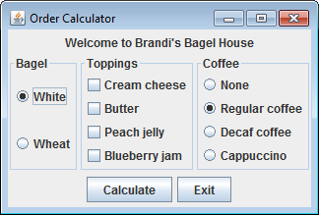

Pressing Calculate button generates the following:

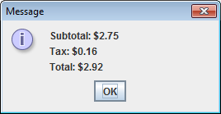

Grading Criteria

|  |  |
| --- | --- |
| Uses JavaFX Components (not Swing or AWT) | 15 |
| Coffee pane | 10 |
| Topping pane | 15 |
| Muffin pane | 15 |
| Displays subtotal, tax, total in separate Stage | 15 |
| GUI is readable, usable (overall user friendliness) | 15 |
| Meets coding standards | 15 |